Homework 2.2: Parent Functions & Transformations Name: _________________________
Math 3

Directions: Give the name of the parent function and describe the transformation represented.
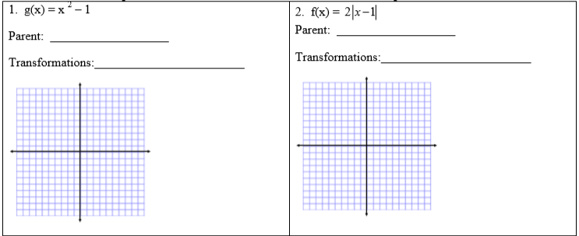
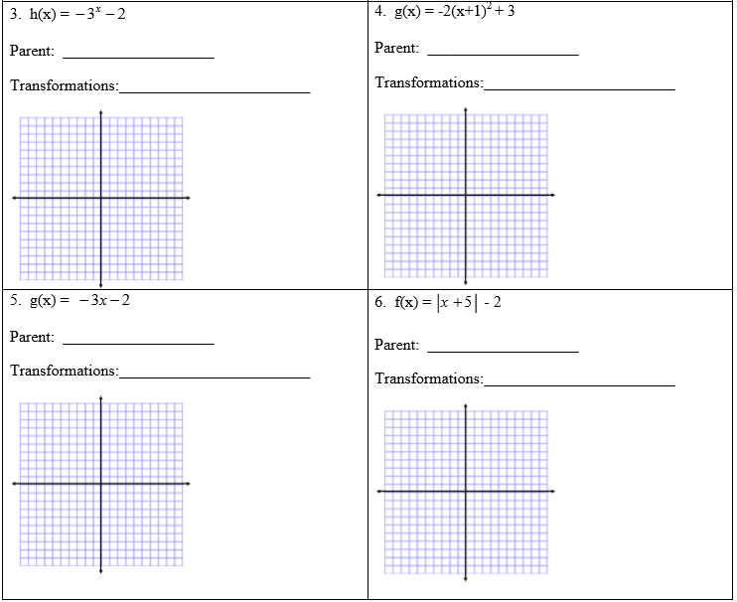
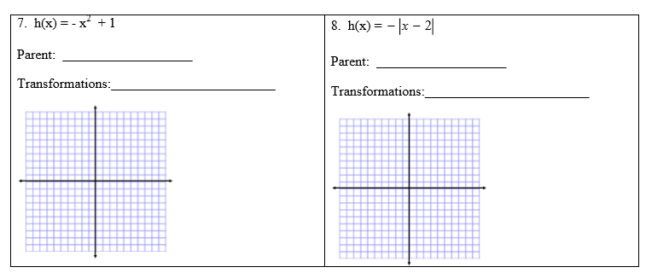

Directions: Given the parent function and a description of the transformation, write the equation of the transformed function, f(x).

